**Atma Ram Sanatan Dharma College  
Delhi University**

Computer Networks

Project: Cisco Packet Tracer

Name: Jyotiswaroop Srivastav

Course: BSc. (Hons) Computer Science

Roll No.: 18023

Submitted to: Dr. Uma Ojha

1. Ipconfig:

Displays all current TCP/IP network configuration values and refreshes Dynamic Host Configuration Protocol (DHCP) and Domain Name System (DNS) settings.

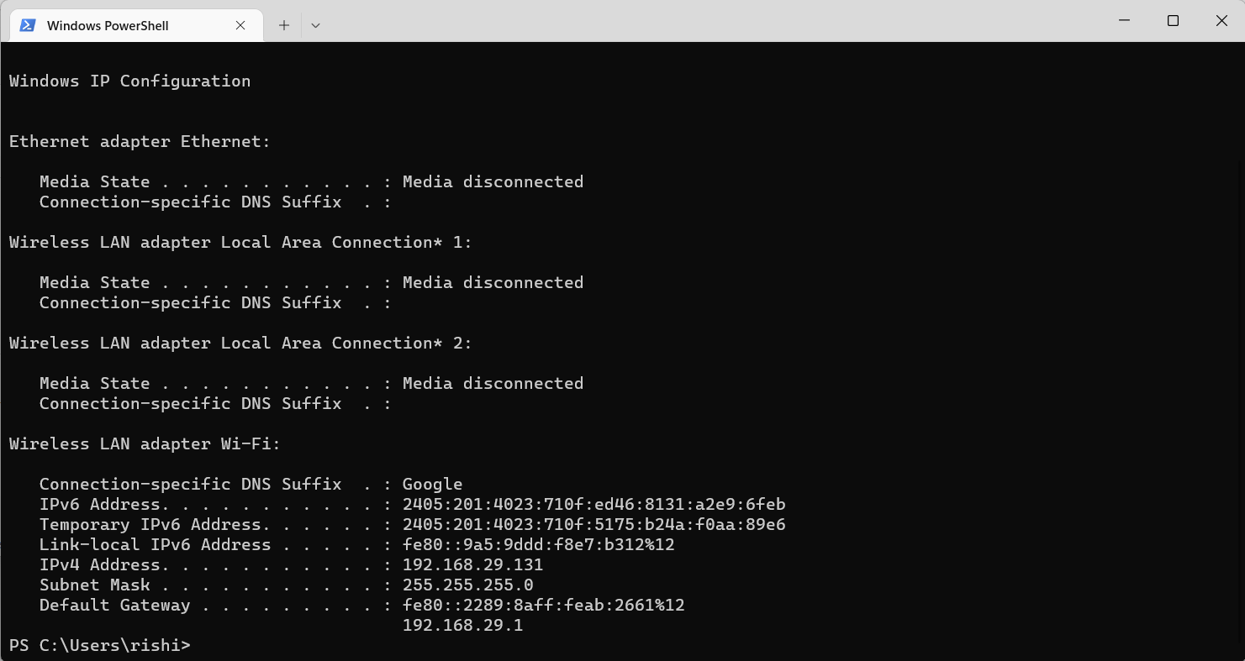

1. Hostname:

Provides the hostname of the host.



1. Ping:

The ping command is a [Command Prompt command](https://www.lifewire.com/list-of-command-prompt-commands-4092302) used to test the ability of the source computer to reach a specified destination computer. It's a simple way to verify that a computer can communicate with another computer or network device.

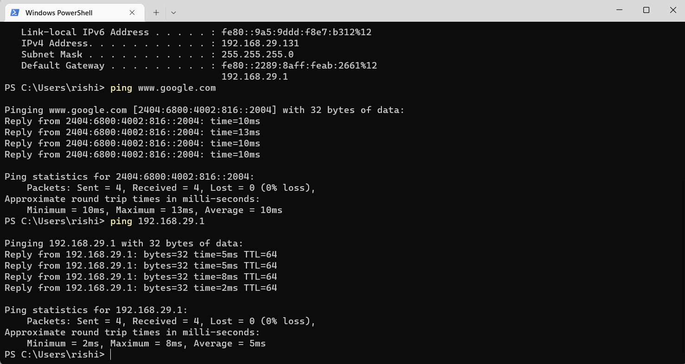

1. Nslookup:

**Nslookup**(stands for “Name Server Lookup”) is a useful command for getting information from the DNS server. It is a network administration tool for querying the Domain Name System (DNS) to obtain domain name or IP address mapping or any other specific DNS record. It is also used to troubleshoot DNS-related problems.

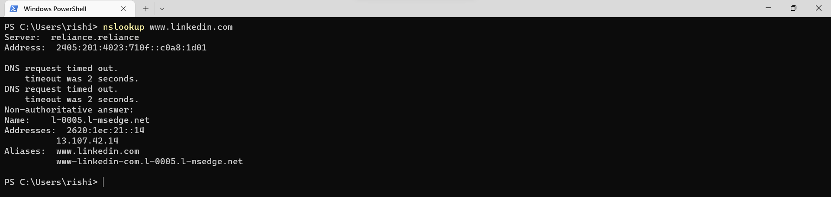

1. Tracert:

**Tracert** command prints the route that a packet takes to reach the host. This command is useful when you want to know about the route and about all the hops that a packet takes. It also prints detail about all the hops that it visits in between.

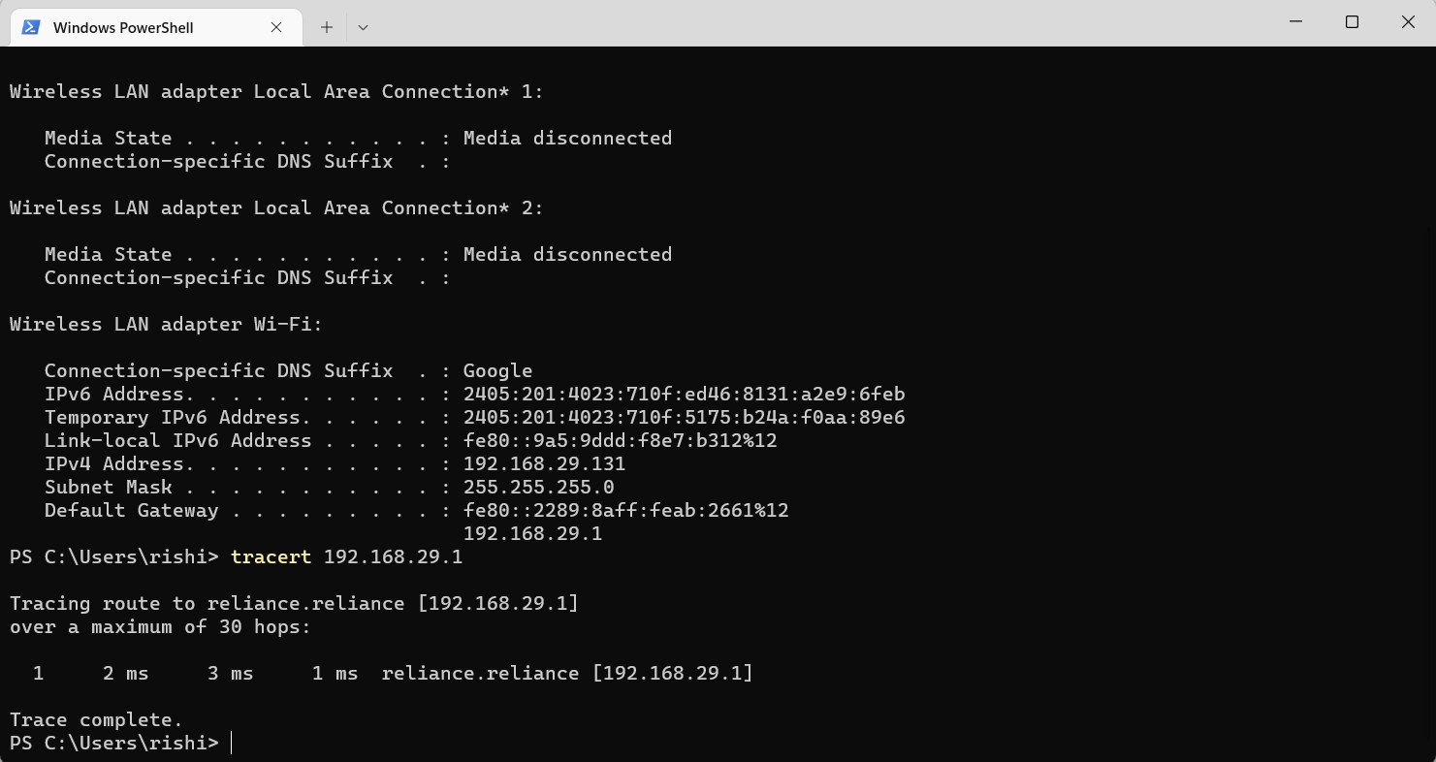

1. Netstat:

Netstat command displays various network related information such as network connections, routing tables, interface statistics, masquerade connections, multicast memberships etc.

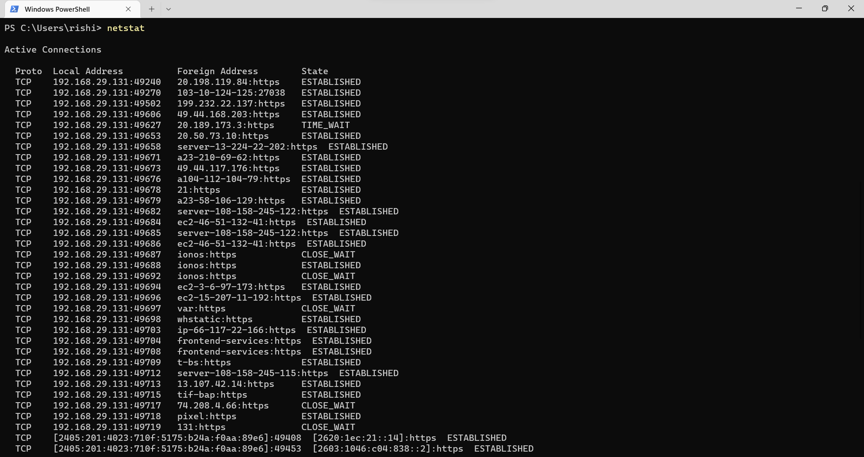

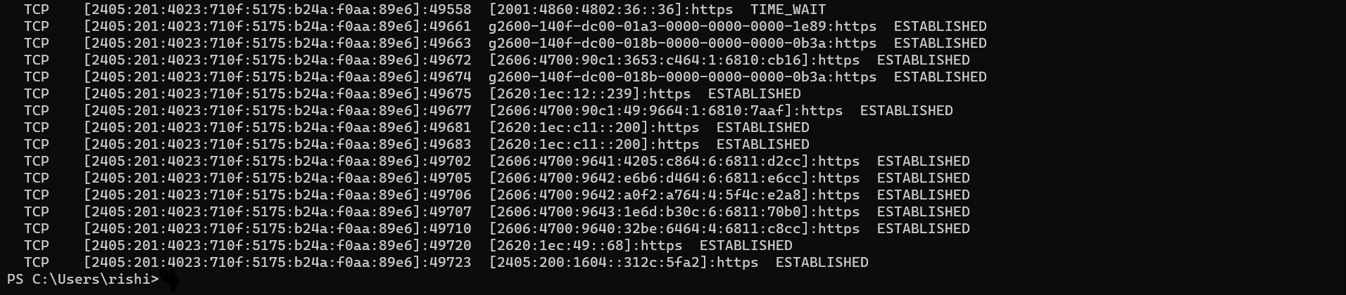

**Simple LAN Network Using DHCP Protocol**

* This is the interface of Cisco Packet Tracer. We have inserted a router 1941, switch 2950-24, three PCs- PC0, PC1 and PC2, a laptop and a server into our network environment.

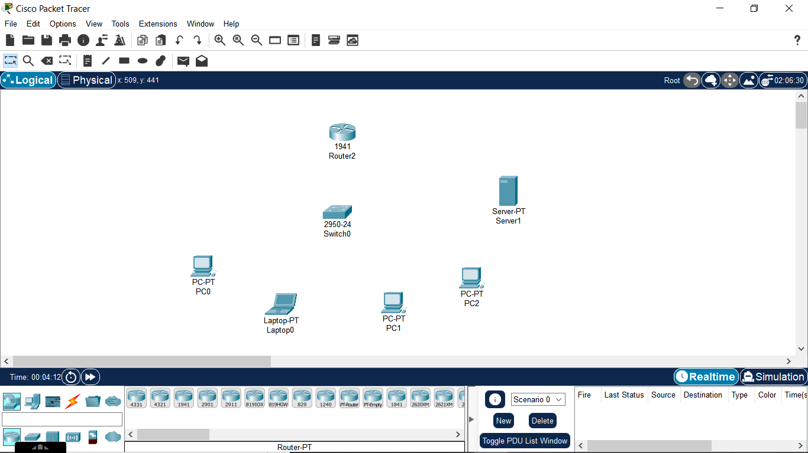

* Then we connect the router to switch and all other devices on the network to the switch.

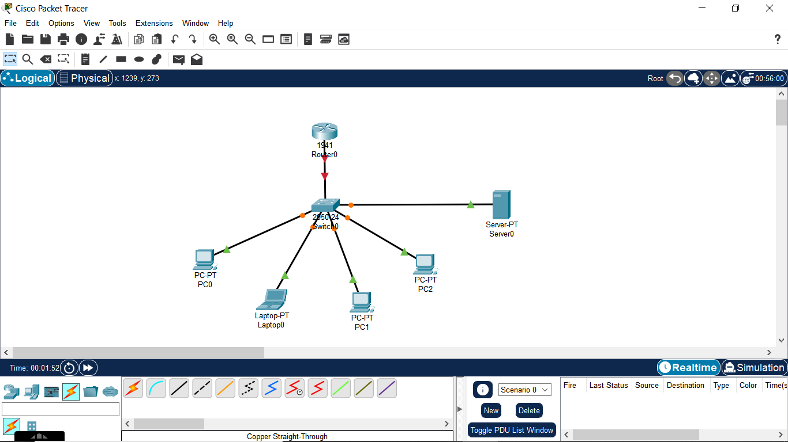

* To establish a connection between router and switch, we need to configure the router settings and assign IP address using following commands.

1. Enable

2. Configure terminal

3. Interface gigabitethernet 0/0

4. IP address 196.168.0.1 255.255.255.0

5. No shut

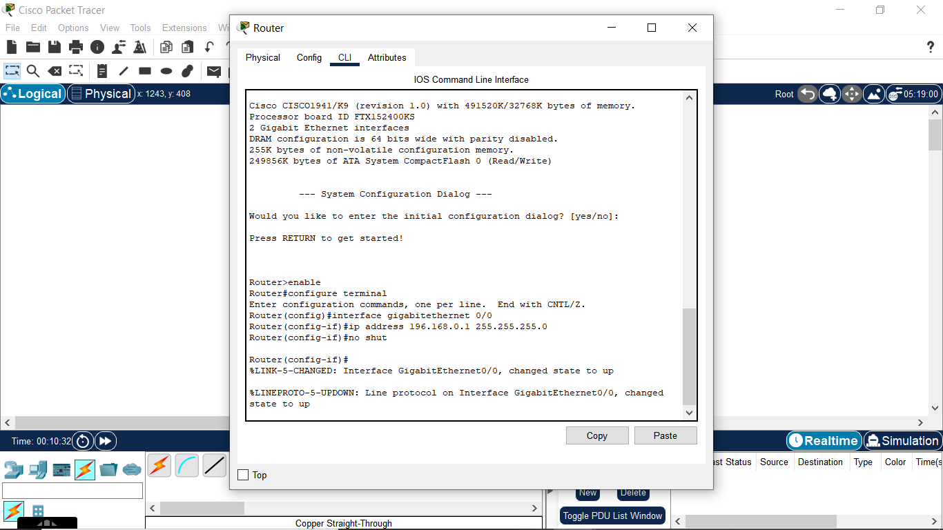

* We also need to configure the DHCP protocol in the router using following commands.

1. IP DHCP pool XYZ

2. Network 196.168.1.1 255.255.255.0

3. Default-router 196.168.0.1

4. DNS-Server 196.168.1.254

5. Exit

Then, we run command write memory to write the changes in the memory, so that they can come into effect.

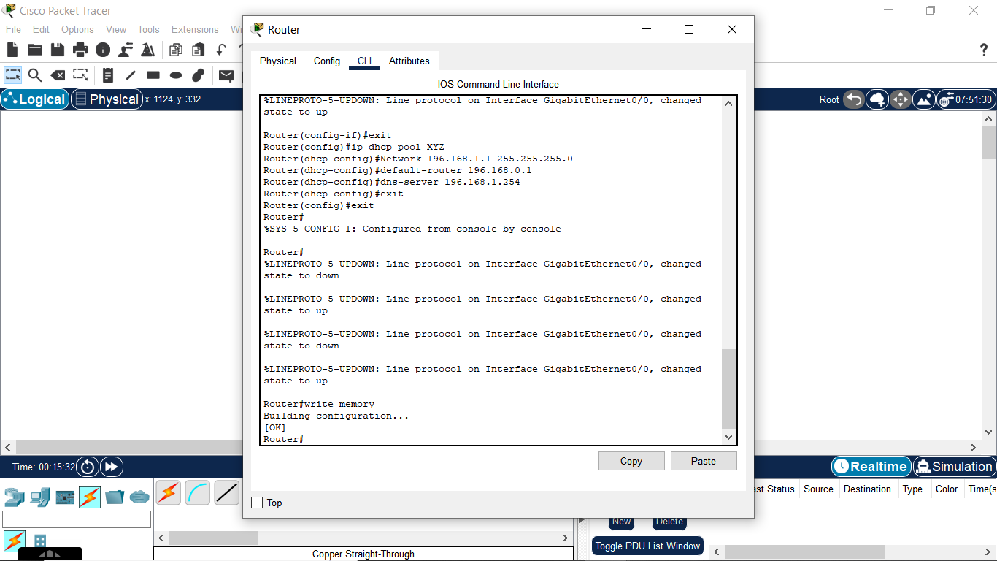

* Now, we will assign IP addresses to the end devices using DHCP Protocol. In this method, IP address and MAC address are automatically derived from the DHCP protocol defined in the router.

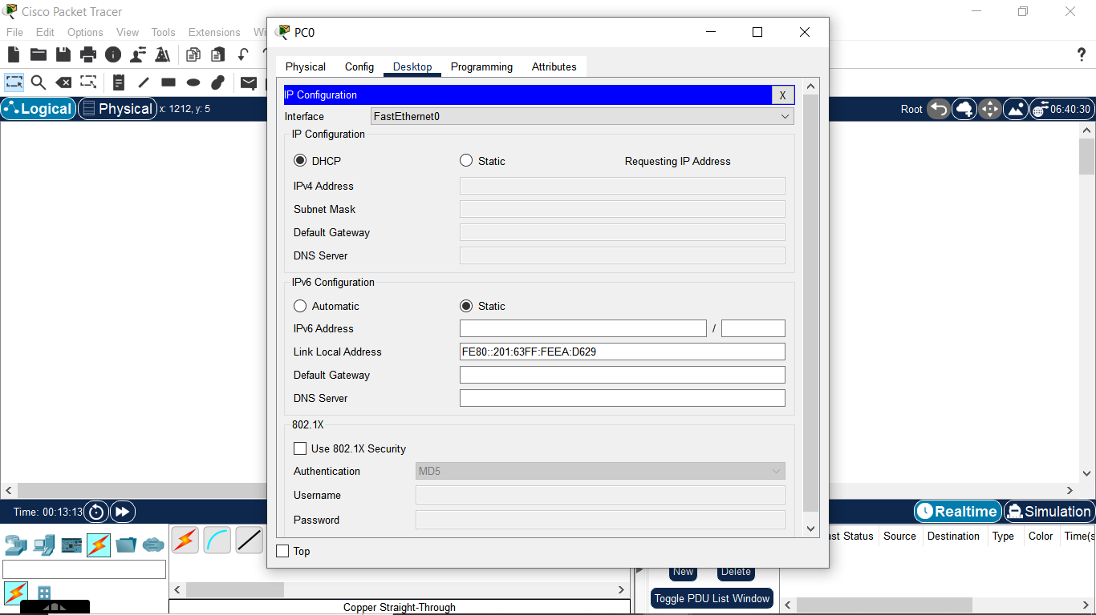

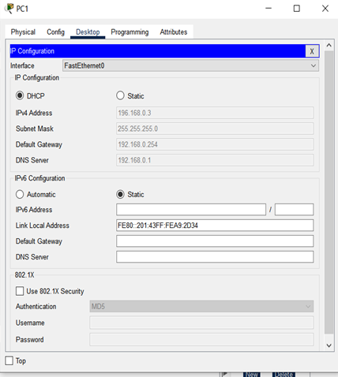

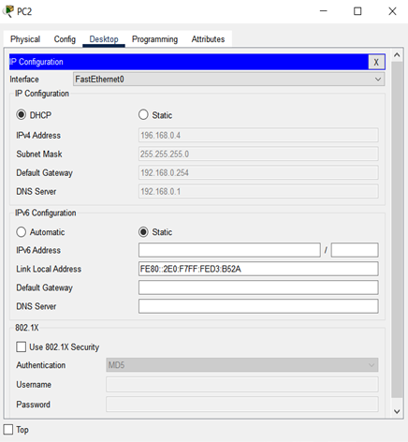

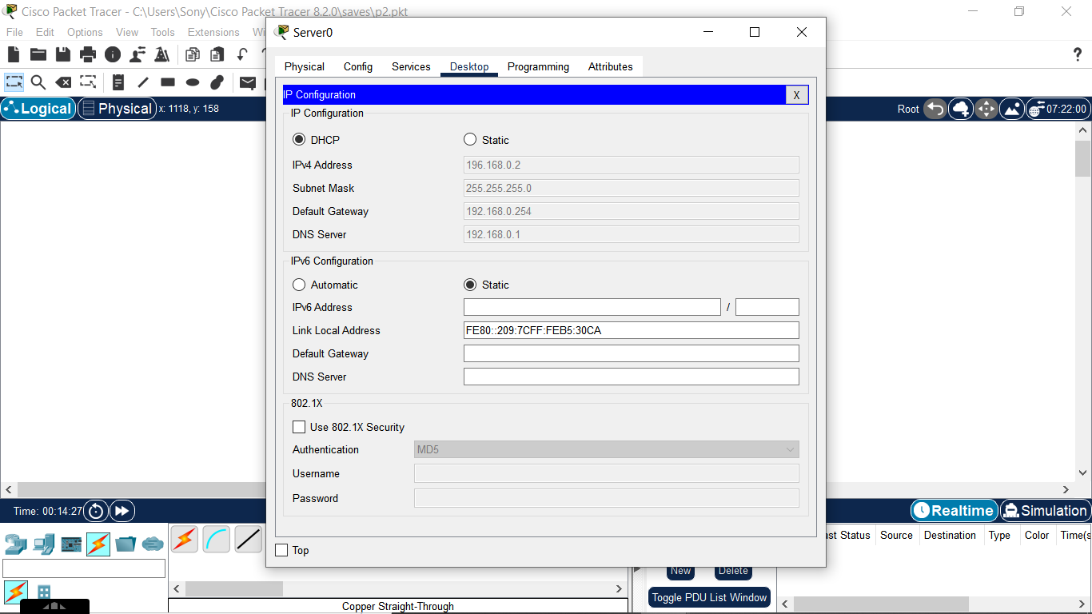

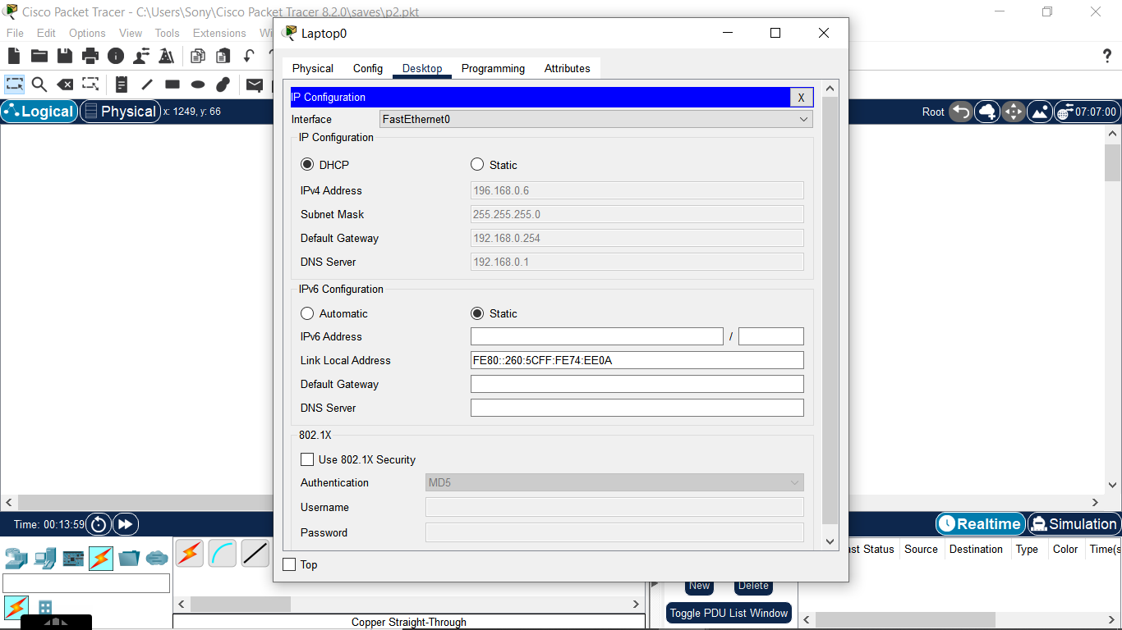

* A network has been established with all the devices having their IP addresses.

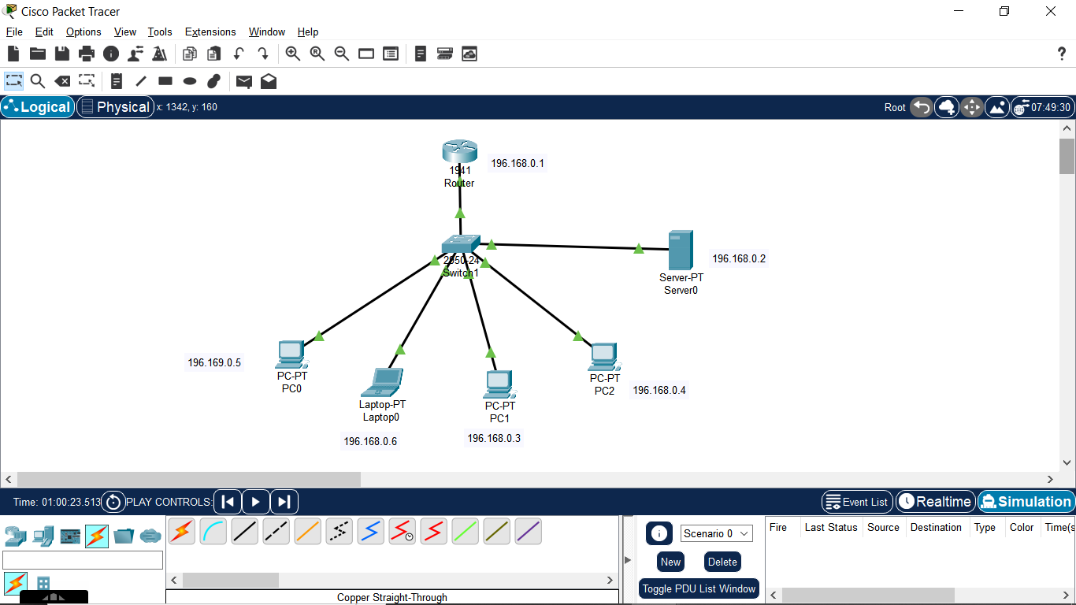

* Now, we simulate the network by sending a ping from one device to another.

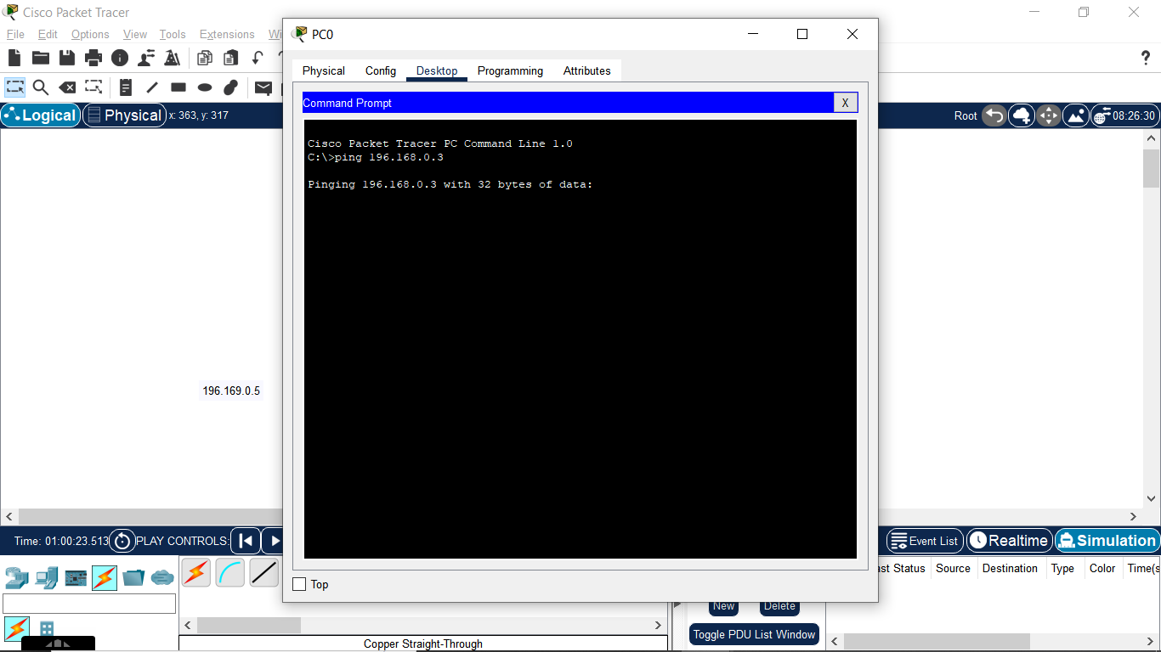

* In the simulation panel, we can see the packet being created at PC0.
* Then it is passed onto switch from where it gets the MAC address of the destination.
* The switch updates the MAC Address of the destination i.e. PC1.
* PC1, on receiving the packet sends the reply.
* The switch gets the reply and send it to the source, PC0.

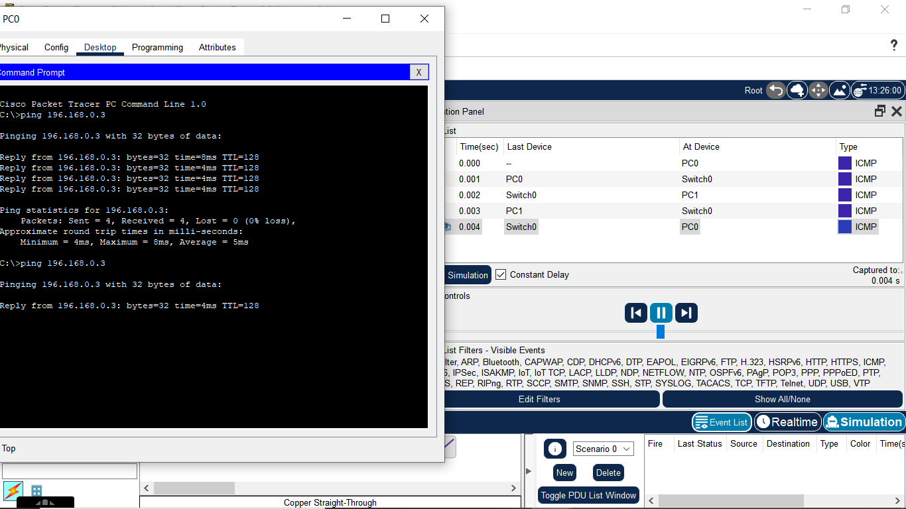

* Outgoing packet details from PC0 to switch

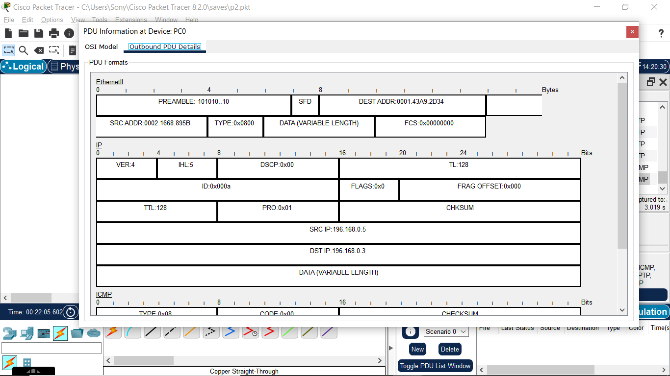

* Incoming packet details to switch

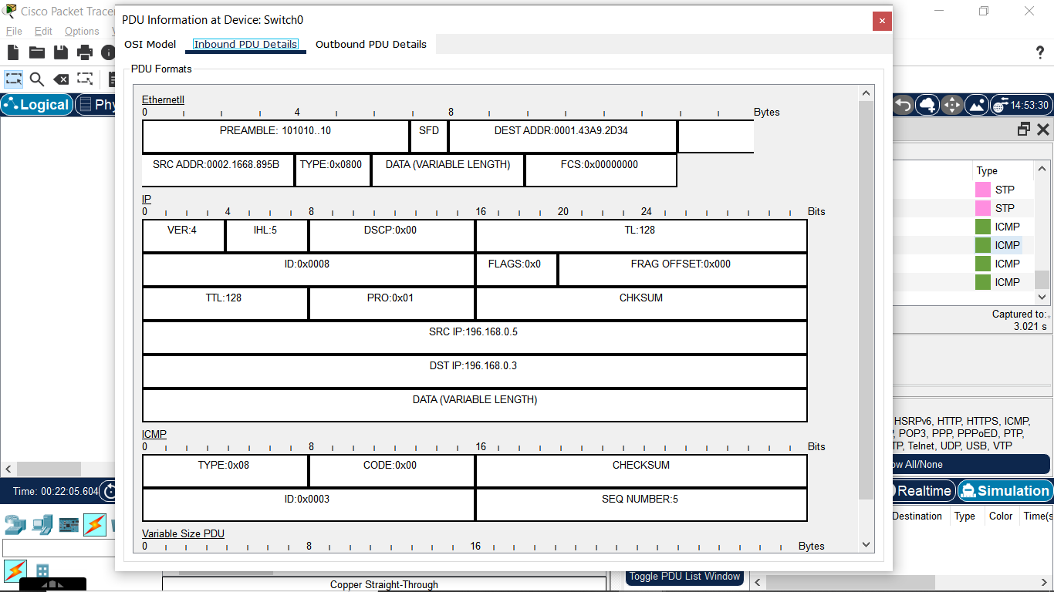

* Outgoing packet details from switch to PC1

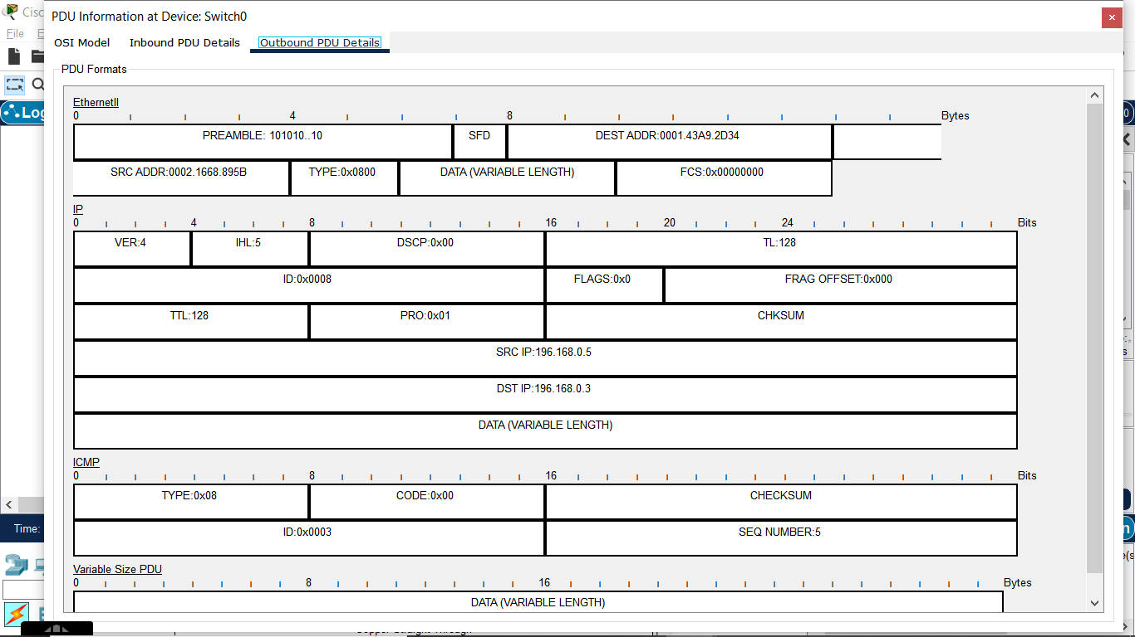

* Incoming packet details from switch to PC1

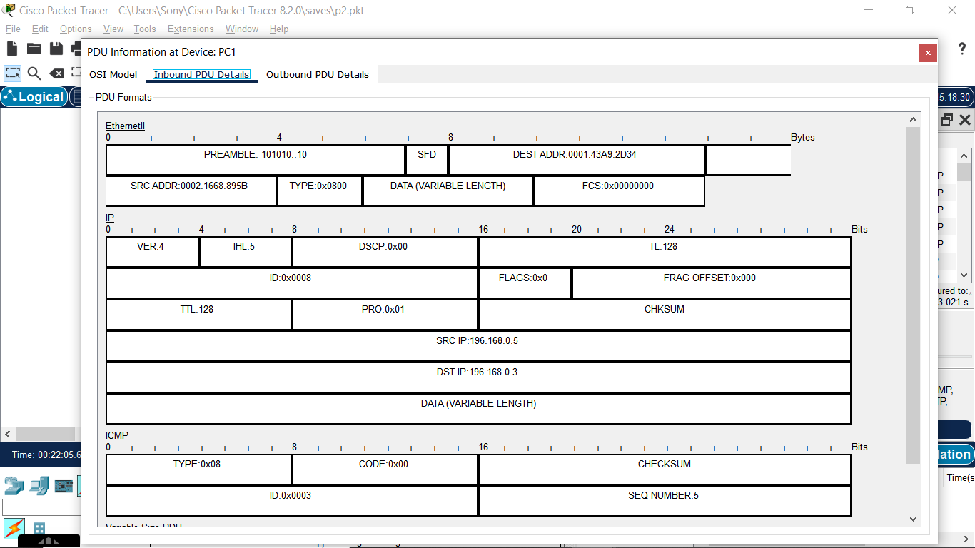

* Outgoing packet details from PC1 to switch

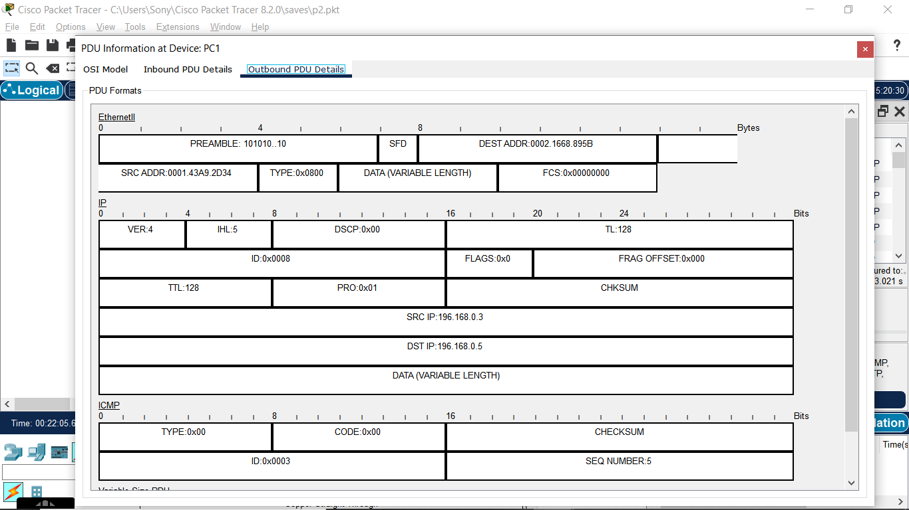

* Incoming packet details from PC1 to switch

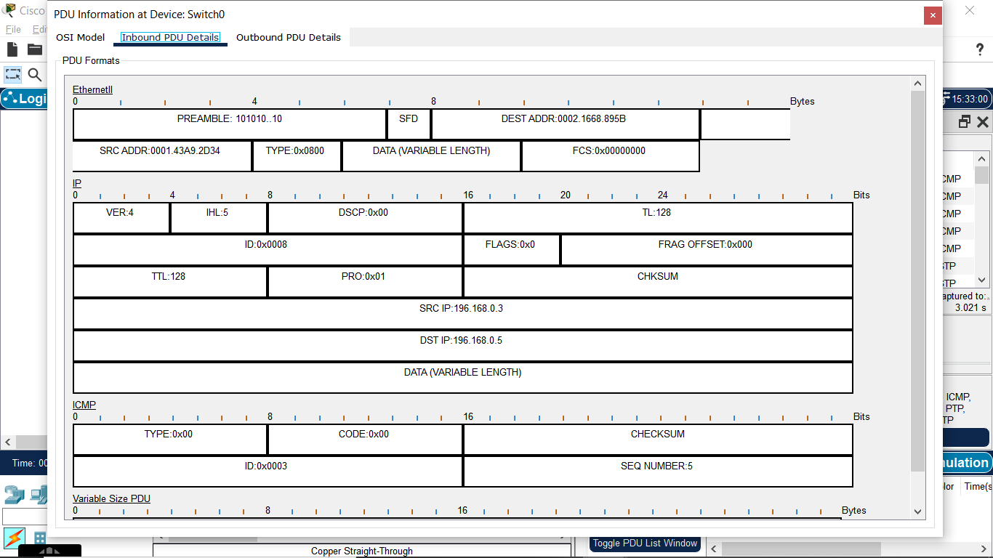

* Outgoing packet details from switch to PC0

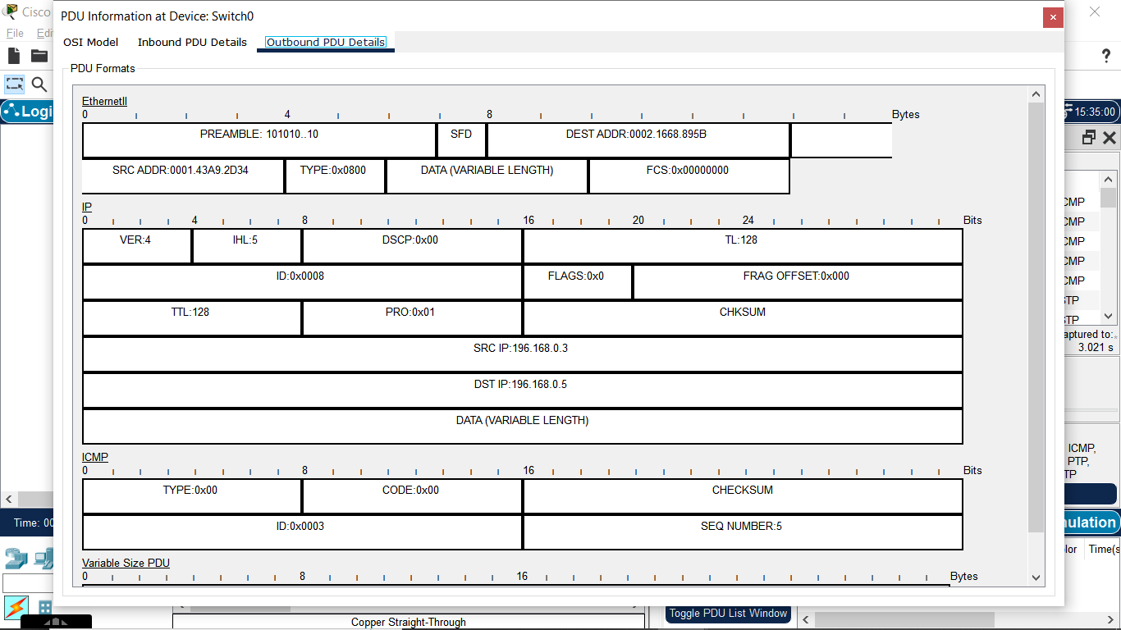

* Incoming packet details from switch to PC0

